

A Project Report On

**“CLASS ATTENDANCE REGISTER”**

**Submitted By:**

SAGILI KARTHIKEYA

Roll No: 68 Class: XII C

**Under the Guidance of**

Mr. Anoop V S

PGT (Computer Science)

Department of Computer Science

**SAINIK SCHOOL KALIKIRI**

**Department of Computer Science**

**SAINIK SCHOOL KALIKIRI**



This is to certify that **Cdt.S Karthikeya,** Roll No. 68 of Class XII has prepared the report on the Project entitled **“CLASS ATTENDANCE REGISTER”**. The report is the result of his efforts & endeavors. The report is found worthy of acceptance as final project report for the subject Computer Science of Class XII.

Signature Signature

(Internal Examiner) (External Examiner)



**DECLARATION**

I hereby declare that the project work entitled

“**CLASS ATTENDANCE REGISTER**”, submitted to Department

of **Computer Science**, SAINIK SCHOOL KALIKIRI is **prepared**

**by me**. All the **coding** is the result of my **personal efforts**.

**Cdt.S Karthikeya** Roll No : 68

Class: XII C

SAINIK SCHOOL KALIKIRI



**ACKNOWLEDGEMENT**

I would like to express a deep sense of thanks & gratitude to my **project**

**guide Mr. Anoop V S** Sir for guiding me immensely through the course of

the project. He always evinced keen interest in my work. His constructive

advice & **constant motivation** have been responsible for the **successful**

completion of this project.

My sincere thanks go to **Lt Col Susheel Kumar Mahapatro SM ,** our

**Offg** **Principal** sir, for his co-ordination in extending every **possible**

**support** for the completion of this project.

I also thanks to my **parents** for their **motivation & support**. I must

thanks to my **classmates** for their timely help & support for **compilation**

of this **project**.

**Last but not the least, I would like to thank all those who had helped**

**directly or indirectly towards the completion of this project.**

**Cdt.S Karthikeya** Roll No : 68

Class: XII C

SAINIK SCHOOL KALIKIRI

**CONTENTS**

1. Project Description .........................
2. Code of the Project ............................
3. Output Screens …..............................
4. Bibliography .....................................
   * + 1. **PROJECT DESCRIPTION**

# This project is about e-class attendance .

# The regular class attendance system became a time consuming task for a

# teacher .This system will record the attendance of students and teaching

# staff to help reduce the administrative work load.

# Therefore this system will provide the information and statistics about the

# students attendance regularly.

**Usage in real life .**

**1** Speed and Accuracy.

**2** Reduce paper work and save time.

**3** Automatic report generation.

**4** Tracks individual attendance at any time.

**5** Eliminate duplicate data entry and errors.

**2. Code of the Project**

**import mysql.connector as sql**

**mycon =sql.connect(host="localhost",user="root",passwd="12345",database="sskal")**

**cursor=mycon.cursor()**

**print("✨✨✨✨✨✨✨✨✨✨✨✨✨✨✨✨✨✨✨✨✔✔✘✔ CLASS ATTENDANCE REGISTER ✘✔✘✘**

**✨✨✨✨✨✨✨✨✨✨✨✨✨✨✨✨✨✨✨✨")**

**print("✨✨✨✨✨✨✨✨✨✨✨✨✨✨✨✨✨✨✨✨✨✨✨✨✨✨✨✨✨✨✨✨✨✨✨✨✨✨✨✨✨✨✨✨✨✨✨✨✨✨✨✨✨✨✨✨✨✨✨✨✨✨✨✨")**

**print('✍To login press-(1) or Register press-(0)')**

**a=int(input("Enter your responce:"))**

**if a==0:**

**fname=input('enter your first name✍:')**

**lname=input('enter your last name✍:')**

**sub={'P':'Physics','C':'Chemistry','M':'Mathematics','E':'English','CS':'ComputerScience'}**

**for i in sub.keys():**

**print(i,'-',sub[i])**

**subcode=input('Enter your subjectCode✍:')**

**subject=sub[subcode]**

**uid=input('enter your user Id✍:')**

**passwd=input('enter your password✍:')**

**cursor=mycon.cursor()**

**cursor.execute("INSERT INTO login(subject,fname,lname,uid,passwd)**

**VALUES('{}','{}','{}','{}','{}')".format(subject,fname,lname,uid,passwd))**

**mycon.commit()**

**print('Registered Successfully....✔✔')**

**if a==1:**

**uid=input('Enter your usernsme✍:')**

**passwd=input('enter your password✍:')**

**cursor=mycon.cursor()**

**cursor.execute("SELECT * FROM login WHERE uid='{}' AND passwd='{}'".format(uid,passwd))**

**data=cursor.fetchmany(1)**

**count=cursor.rowcount**

**lst=list(data)**

**if lst==[]:**

**print('✘Invalid Username or passwrd.........please try again...!')**

**else:**

**print('Logined successfully......✔✔')**

**while 1<10:**

**print("✨✨✨✨✨✨✨✨✨✨✨✨✨✨✨✨✨✨✨✨✔✔✘✔ WELCOME TO MAINMENU ✘✔✘✘**

**✨✨✨✨✨✨✨✨✨✨✨✨✨✨✨✨✨✨✨✨")**

**print("✨✨✨✨✨✨✨✨✨✨✨✨✨✨✨✨✨✨✨✨✨✨✨✨✨✨✨✨✨✨✨✨✨✨✨✨✨✨✨✨✨✨✨✨✨✨✨✨✨✨✨✨✨✨✨✨✨✨✨✨✨")**

**print('✔.To Mark Attendence of Today✍ -PRESS(1)')**

**print('✔.To Make Changes in Attendence✍ -PRESS(2)')**

**print('✘.To View Attendence of Cadets✍ -PRESS(3)')**

**print('✔.Enroll a New Cadet✍ -PRESS(4)')**

**print('✘.To Exit ... -PRESS(5)')**

**input2=int(input('Enter your responce here✍: '))**

**if input2==1:**

**cursor=mycon.cursor()**

**date=input('Enter Todays Date(DD_MM_YYYY)✍:')**

**sub={'P':'Physics','C':'Chemistry','M':'Mathematics','E':'English','CS':'ComputerScience'}**

**for i in sub.keys():**

**print(i,'-',sub[i])**

**subcode=input('Enter your subjectCode✍:')**

**subject=sub[subcode]**

**if subject==sub['P']:**

**st="CREATE TABLE attendence (rollno int(5), "**

**qr=" VARCHAR(2))"**

**a=st+date+qr**

**cursor.execute(a)**

**cursor.execute("SELECT rollno FROM physics")**

**data=cursor.fetchall()**

**lst=[]**

**for i in data:**

**for j in i:**

**lst.append(j)**

**#print(lst)**

**for k in lst:**

**print("✍P-(Present) or A-(Absent) for the rollno-",k)**

**input123=input("Mark the attendence✍:")**

**st="INSERT INTO attendence(rollno,"**

**qr=") VALUES(%s,%s)"**

**values=(k,input123)**

**ask=st+date+qr**

**#print(ask)**

**cursor.execute(ask,values)**

**mycon.commit()**

**st="ALTER TABLE physics ADD COLUMN "**

**rt=" TINYINT UNSIGNED DEFAULT 0"**

**b=st+date+rt**

**#print(b)**

**cursor.execute(b)**

**mycon.commit()**

**st=" ALTER TABLE physics MODIFY "**

**tr=" VARCHAR(2)"**

**b=st+date+tr**

**#print(b)**

**cursor.execute(b)**

**mycon.commit()**

**ab="UPDATE physics t1 INNER JOIN attendence t2 ON t1.rollno=t2.rollno SET t1."**

**bc="=t2."**

**b=ab+date+bc+date**

**#print(b)**

**cursor.execute(b)**

**mycon.commit()**

**cursor.execute("DROP TABLE attendence")**

**mycon.commit()**

**ans=input("✔If you want to continue press-(y) or else press-(n):")**

**if ans=='y':**

**continue**

**else:**

**break**

**elif subject==sub['C']:**

**st="CREATE TABLE attendence (rollno int(5), "**

**qr=" VARCHAR(2))"**

**a=st+date+qr**

**cursor.execute(a)**

**cursor.execute("SELECT rollno FROM chemistry")**

**data=cursor.fetchall()**

**lst=[]**

**for i in data:**

**for j in i:**

**lst.append(j)**

**#print(lst)**

**for k in lst:**

**print("✍P-(Present) or A-(Absent) for the rollno-",k)**

**input123=input("Mark the attendence✍:")**

**st="INSERT INTO attendence(rollno,"**

**qr=") VALUES(%s,%s)"**

**values=(k,input123)**

**ask=st+date+qr**

**#print(ask)**

**cursor.execute(ask,values)**

**mycon.commit()**

**st="ALTER TABLE chemistry ADD COLUMN "**

**rt=" TINYINT UNSIGNED DEFAULT 0"**

**b=st+date+rt**

**#print(b)**

**cursor.execute(b)**

**mycon.commit()**

**st=" ALTER TABLE chemistry MODIFY "**

**tr=" VARCHAR(2)"**

**b=st+date+tr**

**#print(b)**

**cursor.execute(b)**

**mycon.commit()**

**ab="UPDATE chemistry t1 INNER JOIN attendence t2 ON t1.rollno=t2.rollno SET t1."**

**bc="=t2."**

**b=ab+date+bc+date**

**#print(b)**

**cursor.execute(b)**

**mycon.commit()**

**cursor.execute("DROP TABLE attendence")**

**mycon.commit()**

**ans=input("✔If you want to continue press-(y) or else press-(n):")**

**if ans=='y':**

**continue**

**else:**

**break**

**elif subject==sub['E']:**

**st="CREATE TABLE attendence (rollno int(5), "**

**qr=" VARCHAR(2))"**

**a=st+date+qr**

**cursor.execute(a)**

**cursor.execute("SELECT rollno FROM english")**

**data=cursor.fetchall()**

**lst=[]**

**for i in data:**

**for j in i:**

**lst.append(j)**

**#print(lst)**

**for k in lst:**

**print("✍P-(Present) or A-(Absent) for the rollno-",k)**

**input123=input("Mark the attendence✍:")**

**st="INSERT INTO attendence(rollno,"**

**qr=") VALUES(%s,%s)"**

**values=(k,input123)**

**ask=st+date+qr**

**#print(ask)**

**cursor.execute(ask,values)**

**mycon.commit()**

**st="ALTER TABLE english ADD COLUMN "**

**rt=" TINYINT UNSIGNED DEFAULT 0"**

**b=st+date+rt**

**#print(b)**

**cursor.execute(b)**

**mycon.commit()**

**st=" ALTER TABLE english MODIFY "**

**tr=" VARCHAR(2)"**

**b=st+date+tr**

**#print(b)**

**cursor.execute(b)**

**mycon.commit()**

**ab="UPDATE english t1 INNER JOIN attendence t2 ON t1.rollno=t2.rollno SET t1."**

**bc="=t2."**

**b=ab+date+bc+date**

**#print(b)**

**cursor.execute(b)**

**mycon.commit()**

**cursor.execute("DROP TABLE attendence")**

**mycon.commit()**

**ans=input("✔If you want to continue press-(y) or else press-(n):")**

**if ans=='y':**

**continue**

**else:**

**break**

**elif subject==sub['M']:**

**st="CREATE TABLE attendence (rollno int(5), "**

**qr=" VARCHAR(2))"**

**a=st+date+qr**

**cursor.execute(a)**

**cursor.execute("SELECT rollno FROM mathematics")**

**data=cursor.fetchall()**

**lst=[]**

**for i in data:**

**for j in i:**

**lst.append(j)**

**#print(lst)**

**for k in lst:**

**print("✍P-(Present) or A-(Absent) for the rollno-",k)**

**input123=input("Mark the attendence✍:")**

**st="INSERT INTO attendence(rollno,"**

**qr=") VALUES(%s,%s)"**

**values=(k,input123)**

**ask=st+date+qr**

**#print(ask)**

**cursor.execute(ask,values)**

**mycon.commit()**

**st="ALTER TABLE mathematics ADD COLUMN "**

**rt=" TINYINT UNSIGNED DEFAULT 0"**

**b=st+date+rt**

**#print(b)**

**cursor.execute(b)**

**mycon.commit()**

**st=" ALTER TABLE mathematics MODIFY "**

**tr=" VARCHAR(2)"**

**b=st+date+tr**

**#print(b)**

**cursor.execute(b)**

**mycon.commit()**

**ab="UPDATE mathematics t1 INNER JOIN attendence t2 ON t1.rollno=t2.rollno SET t1."**

**bc="=t2."**

**b=ab+date+bc+date**

**#print(b)**

**cursor.execute(b)**

**mycon.commit()**

**cursor.execute("DROP TABLE attendence")**

**mycon.commit()**

**ans=input("✔If you want to continue press-(y) or else press-(n):")**

**if ans=='y':**

**continue**

**else:**

**break**

**elif subject==sub['CS']:**

**st="CREATE TABLE attendence (rollno int(5), "**

**qr=" VARCHAR(2))"**

**a=st+date+qr**

**cursor.execute(a)**

**cursor.execute("SELECT rollno FROM computerscience")**

**data=cursor.fetchall()**

**lst=[]**

**for i in data:**

**for j in i:**

**lst.append(j)**

**#print(lst)**

**for k in lst:**

**print("✍P-(Present) or A-(Absent) for the rollno-",k)**

**input123=input("Mark the attendence✍:")**

**st="INSERT INTO attendence(rollno,"**

**qr=") VALUES(%s,%s)"**

**values=(k,input123)**

**ask=st+date+qr**

**#print(ask)**

**cursor.execute(ask,values)**

**mycon.commit()**

**st="ALTER TABLE computerscience ADD COLUMN "**

**rt=" TINYINT UNSIGNED DEFAULT 0"**

**b=st+date+rt**

**#print(b)**

**cursor.execute(b)**

**mycon.commit()**

**st=" ALTER TABLE computerscience MODIFY "**

**tr=" VARCHAR(2)"**

**b=st+date+tr**

**#print(b)**

**cursor.execute(b)**

**mycon.commit()**

**ab="UPDATE computerscience t1 INNER JOIN attendence t2 ON t1.rollno=t2.rollno SET t1."**

**bc="=t2."**

**b=ab+date+bc+date**

**#print(b)**

**cursor.execute(b)**

**mycon.commit()**

**cursor.execute("DROP TABLE attendence")**

**mycon.commit()**

**ans=input("✔If you want to continue press-(y) or else press-(n):")**

**if ans=='y':**

**continue**

**else:**

**break**

**if input2==2:**

**cursor=mycon.cursor()**

**print("✔To change attendance data✍ PRESS-(1)")**

**print("✔To change users password✍ PRESS-(2)")**

**print("✔To change details of the cadet✍ PRESS-(3)")**

**b=int(input("Enter your responce here✍:"))**

**if b==1:**

**sub={'P':'Physics','C':'Chemistry','M':'Mathematics','E':'English','CS':'ComputerScience'}**

**for i in sub.keys():**

**print(i,'-',sub[i])**

**subcode=input('Enter your subjectCode✍:')**

**subject=sub[subcode]**

**date=input('Enter The Date you want to change (DD_MM_YYYY):')**

**rollno=int(input("enter the rollno of the cadet✍:"))**

**attendance=input('Mark the updated attendance(P/A)✍:')**

**cursor=mycon.cursor()**

**ab="UPDATE "**

**bc=" SET "**

**cd="=%s"**

**de=" WHERE rollno=%s"**

**ask=ab+subject+bc+date+cd+de**

**#print(ask)**

**values=(attendance,rollno)**

**cursor.execute(ask,values)**

**mycon.commit()**

**ans=input("✔if you want to continue press-(y) or else press-(n)")**

**if ans=='y':**

**continue**

**else:**

**break**

**if b==2:**

**username=input("enter your username✍:")**

**passwd=input("enter your new password✍:")**

**cursor=mycon.cursor()**

**ab="UPDATE login SET passwd=%s WHERE uid=%s"**

**values=(passwd,username)**

**cursor.execute(ab,values)**

**mycon.commit()**

**ans=input("✔if you want to continue press-(y) or else press-(n)")**

**if ans=='y':**

**continue**

**else:**

**break**

**if b==3:**

**rollno=int(input("enter the rollno of the cadet✍:"))**

**cursor=mycon.cursor()**

**st="SELECT * FROM details WHERE rollno=%s"**

**val=(rollno,)**

**cursor.execute(st,val)**

**data=cursor.fetchmany(1)**

**for i in data:**

**print(data)**

**print("Enter the updated details of the cadet below✍:")**

**name=input("Enter the name of the cadet✍:")**

**class1=int(input("enter the class✍-"))**

**section=input("enter the section✍:")**

**house=input("enter the house name✍:")**

**st="UPDATE details SET name=%s,class=%s,section=%s,house=%s WHERE rollno=%s"**

**val=(name,class1,section,house,rollno)**

**cursor.execute(st,val)**

**mycon.commit()**

**print("The updated details are:")**

**st="SELECT * FROM details WHERE rollno=%s"**

**val=(rollno,)**

**cursor.execute(st,val)**

**data=cursor.fetchmany(1)**

**for i in data:**

**print(data)**

**ans=input("✔if you want to continue press-(y) or else press-(n)")**

**if ans=='y':**

**continue**

**else:**

**break**

**if input2==3:**

**cursor=mycon.cursor()**

**rollno=int(input("Enter the rollno of the cadet✍:"))**

**sub={'P':'Physics','C':'Chemistry','M':'Mathematics','E':'English','CS':'ComputerScience'}**

**for i in sub.keys():**

**lst=[]**

**m=0**

**n=0**

**a=(sub[i])**

**st="SELECT * FROM "**

**qr=" WHERE rollno=%s"**

**ask=st+a+qr**

**#print(ask)**

**val=(rollno,)**

**cursor.execute(ask,val)**

**data=cursor.fetchmany(1)**

**for i in data:**

**for j in i:**

**lst.append(j)**

**for k in lst:**

**if k=='P':**

**m=m+1**

**else:**

**n=n+1**

**print('✔SUBJECT:-',a)**

**print('✔total no.of periods:-',m+n)**

**print('✔toal no.of periods present:-',m)**

**print('✔total no.of periods absent:-',n)**

**print('✔Overall attendence percentage in the subject:-',(m/(m+n))*100,'%')**

**ans=input("✔if you want to continue press-(y) or else press-(n)")**

**if ans=='y':**

**continue**

**else:**

**break**

**if input2==4:**

**cursor=mycon.cursor()**

**rollno=int(input("enter the rollno. of the cadet✍:"))**

**cursor.execute("SELECT rollno FROM details")**

**data=cursor.fetchall()**

**lst=[]**

**for i in data:**

**for j in i:**

**lst.append(j)**

**for k in lst:**

**if k==rollno:**

**print("This rollno already exists......Try again !")**

**ans=input("✔if you want to continue press-(y) or else press-(n)")**

**if ans=='y':**

**continue**

**else:**

**break**

**else:**

**name=input("enter the name of the cadet✍:")**

**class1=int(input("enter the class✍:"))**

**section=input("enter the section✍:")**

**house=input("enter the house name✍:")**

**cursor.execute("INSERT INTO details(rollno,name,class,section,house)**

**VALUES({},'{}','{}','{}','{}')".format(rollno,name,class1,section,house))**

**mycon.commit()**

**sub={'P':'Physics','C':'Chemistry','M':'Mathematics','E':'English','CS':'ComputerScience'}**

**for i in sub.keys():**

**a=(sub[i])**

**ab="INSERT INTO "**

**bc="(rollno) VALUES(%s)"**

**val=(rollno,)**

**ask=ab+a+bc**

**cursor.execute(ask,val)**

**mycon.commit()**

**print("Data inserted successfully...")**

**ans=input("✔if you want to continue press-(y) or else press-(n)")**

**if ans=='y':**

**continue**

**else:**

**break**

**if input2==5:**

**print("Thank you.......✍")**

**break**

**3. Output Screens**

**To Register as a teacher or staff member…**

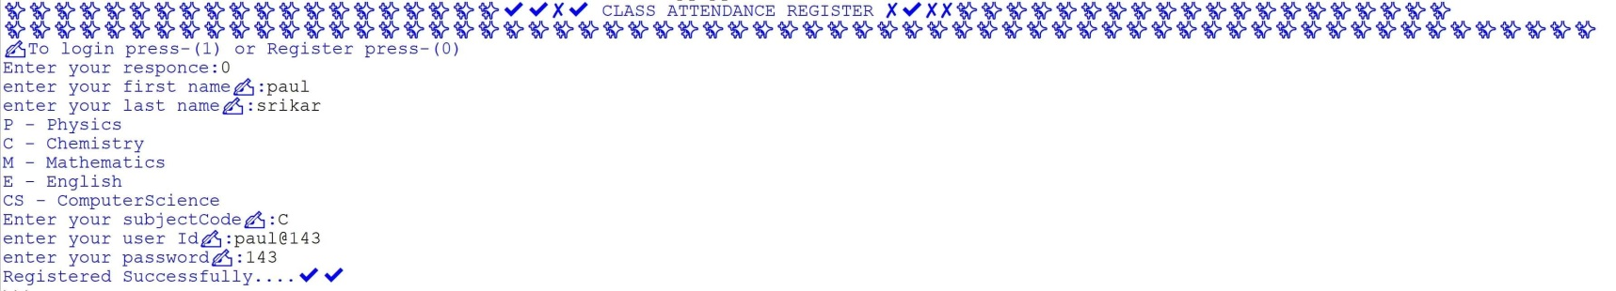

**Main menu…**

**1. To mark attendance**

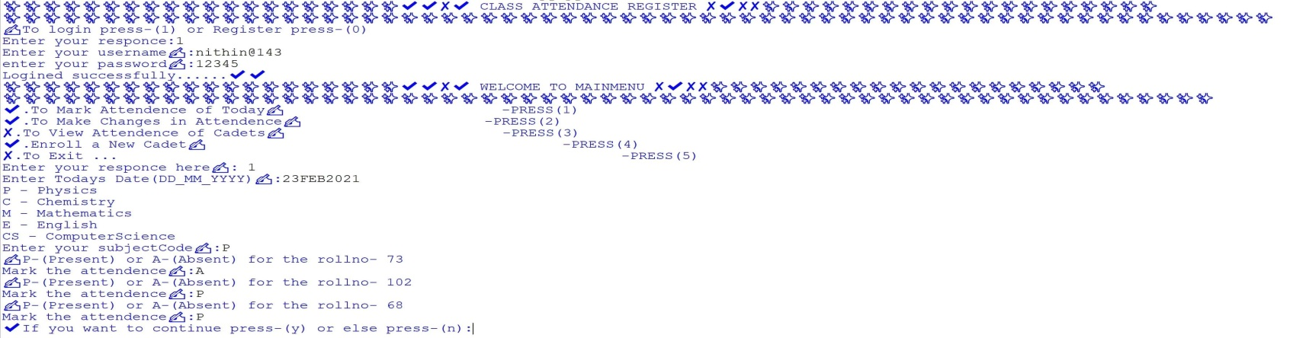

**To make changes in attendance….**

**a To change cadets attendance data….**

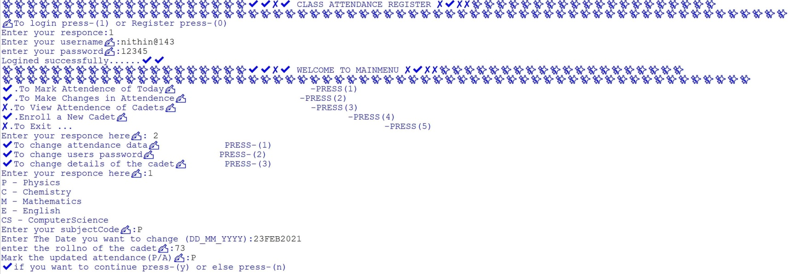

**b To change user password…..**

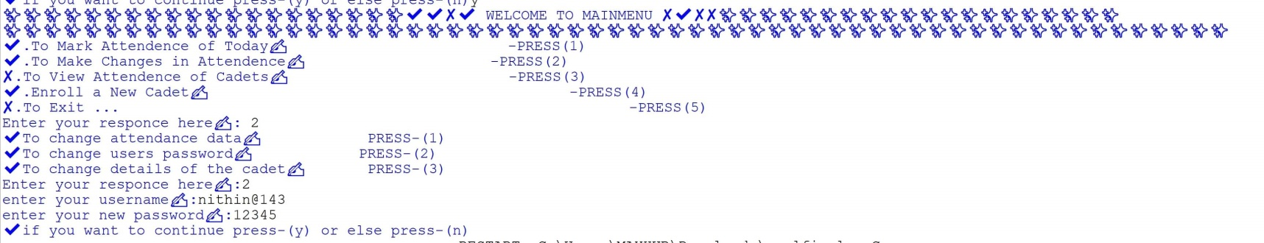

**c To change details of the cadets….**

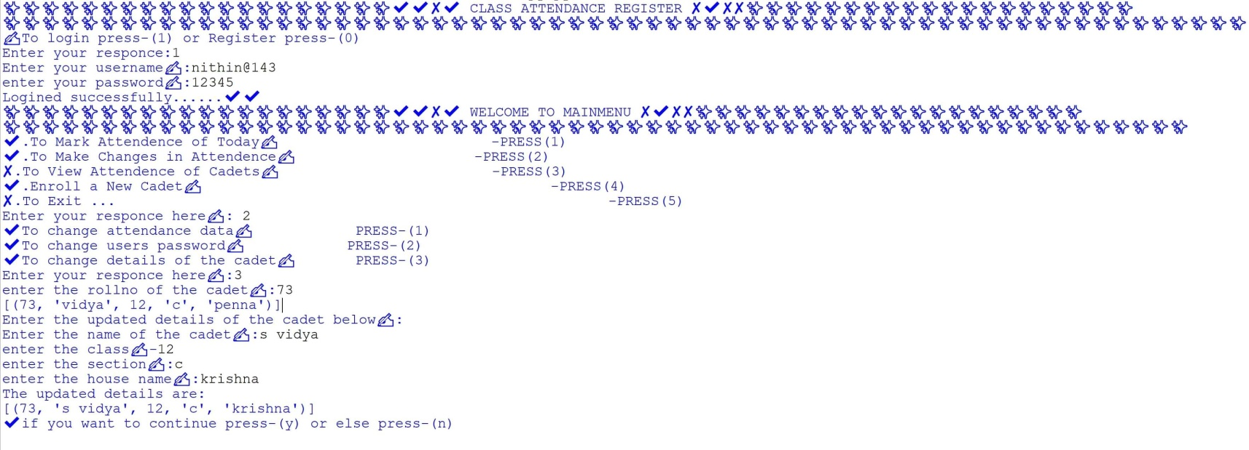

**3 To view attendance of the cadets…..**

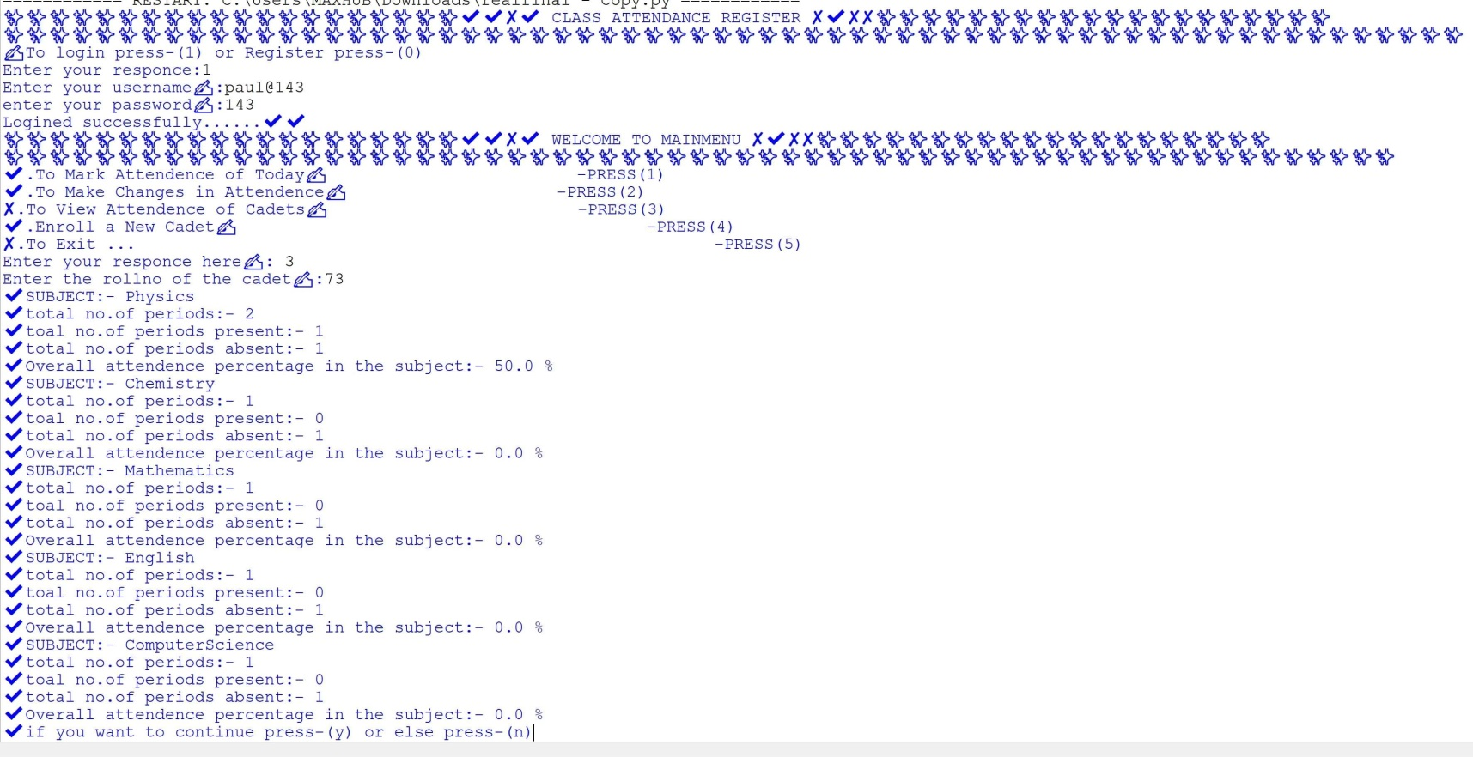

**4 Enroll a new cadet…..**

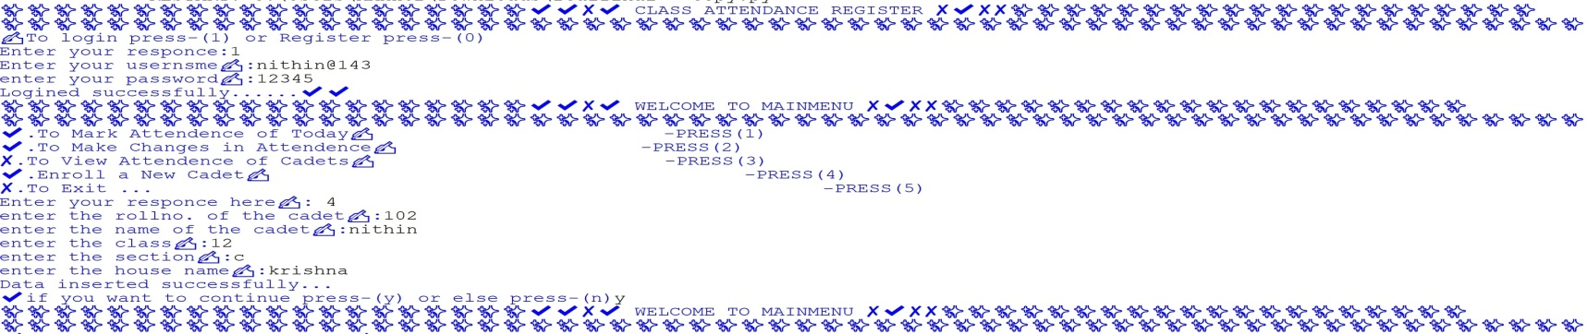

**5 Exit…..**

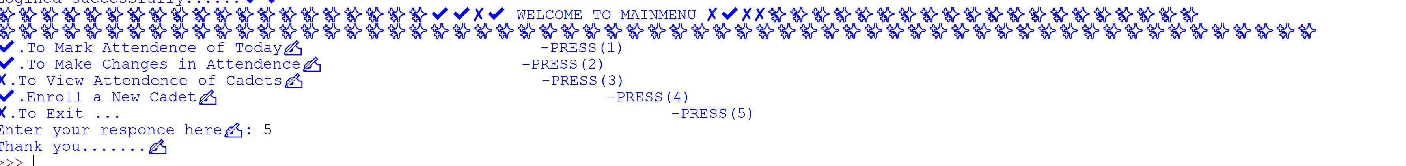

**4. BIBLIOGRAPHY**

* Computer Science with Python [Textbook XII] by Sumita Arora.



A Project Report On

**“CLASS ATTENDANCE REGISTER”**

**Submitted By:**

SAGINA VIDYASAGAR SAI PADAL

Roll No: 73 Class: XII C

**Under the Guidance of**

Mr. Anoop V S

PGT (Computer Science)

Department of Computer Science

**SAINIK SCHOOL KALIKIRI**

**Department of Computer Science**

**SAINIK SCHOOL KALIKIRI**



This is to certify that **Cdt.Sagina Vidyasagar Sai Padal,** Roll No. 73 of Class XII has prepared the report on the Project entitled **“CLASS ATTENDANCE REGISTER”**. The report is the result of his efforts & endeavors. The report is found worthy of acceptance as final project report for the subject Computer Science of Class XII.

Signature Signature

(Internal Examiner) (External Examiner)



**DECLARATION**

I hereby declare that the project work entitled

“**CLASS ATTENDANCE REGISTER**”, submitted to Department

of **Computer Science**, SAINIK SCHOOL KALIKIRI is **prepared**

**by me**. All the **coding** is the result of my **personal efforts**.

**Cdt.Sagina Vidyasagar Sai Padal**

Roll No: 73

Class: XII C

SAINIK SCHOOL KALIKIRI



**ACKNOWLEDGEMENT**

I would like to express a deep sense of thanks & gratitude to my **project**

**guide Mr. Anoop V S** Sir for guiding me immensely through the course of

the project. He always evinced keen interest in my work. His constructive

advice & **constant motivation** have been responsible for the **successful**

completion of this project.

My sincere thanks go to **Lt Col Susheel Kumar Mahapatro SM ,** our

**Offg** **Principal** sir, for his co-ordination in extending every **possible**

**support** for the completion of this project.

I also thanks to my **parents** for their **motivation & support**. I must

thanks to my **classmates** for their timely help & support for **compilation**

of this **project**.

**Last but not the least, I would like to thank all those who had helped**

**directly or indirectly towards the completion of this project.**

**Cdt.Sagina Vidyasagar Sai Padal**

Roll No: 73

Class: XII C

SAINIK SCHOOL KALIKIRI

**CONTENTS**

1. Project Description .........................
2. Code of the Project ............................
3. Output Screens …..............................
4. Bibliography .....................................
   * + 1. **PROJECT DESCRIPTION**

# This project is about e-class attendance .

# The regular class attendance system became a time consuming task for a

# teacher .This system will record the attendance of students and teaching

# staff to help reduce the administrative work load.

# Therefore this system will provide the information and statistics about the

# students attendance regularly.

**Usage in real life .**

**1** Speed and Accuracy.

**2** Reduce paper work and save time.

**3** Automatic report generation.

**4** Tracks individual attendance at any time.

**5** Eliminate duplicate data entry and errors.

**2. Code of the Project**

**import mysql.connector as sql**

**mycon =sql.connect(host="localhost",user="root",passwd="12345",database="sskal")**

**cursor=mycon.cursor()**

**print("✨✨✨✨✨✨✨✨✨✨✨✨✨✨✨✨✨✨✨✨✔✔✘✔ CLASS ATTENDANCE REGISTER ✘✔✘✘**

**✨✨✨✨✨✨✨✨✨✨✨✨✨✨✨✨✨✨✨✨")**

**print("✨✨✨✨✨✨✨✨✨✨✨✨✨✨✨✨✨✨✨✨✨✨✨✨✨✨✨✨✨✨✨✨✨✨✨✨✨✨✨✨✨✨✨✨✨✨✨✨✨✨✨✨✨✨✨✨✨✨✨✨✨✨✨✨")**

**print('✍To login press-(1) or Register press-(0)')**

**a=int(input("Enter your responce:"))**

**if a==0:**

**fname=input('enter your first name✍:')**

**lname=input('enter your last name✍:')**

**sub={'P':'Physics','C':'Chemistry','M':'Mathematics','E':'English','CS':'ComputerScience'}**

**for i in sub.keys():**

**print(i,'-',sub[i])**

**subcode=input('Enter your subjectCode✍:')**

**subject=sub[subcode]**

**uid=input('enter your user Id✍:')**

**passwd=input('enter your password✍:')**

**cursor=mycon.cursor()**

**cursor.execute("INSERT INTO login(subject,fname,lname,uid,passwd)**

**VALUES('{}','{}','{}','{}','{}')".format(subject,fname,lname,uid,passwd))**

**mycon.commit()**

**print('Registered Successfully....✔✔')**

**if a==1:**

**uid=input('Enter your usernsme✍:')**

**passwd=input('enter your password✍:')**

**cursor=mycon.cursor()**

**cursor.execute("SELECT * FROM login WHERE uid='{}' AND passwd='{}'".format(uid,passwd))**

**data=cursor.fetchmany(1)**

**count=cursor.rowcount**

**lst=list(data)**

**if lst==[]:**

**print('✘Invalid Username or passwrd.........please try again...!')**

**else:**

**print('Logined successfully......✔✔')**

**while 1<10:**

**print("✨✨✨✨✨✨✨✨✨✨✨✨✨✨✨✨✨✨✨✨✔✔✘✔ WELCOME TO MAINMENU ✘✔✘✘**

**✨✨✨✨✨✨✨✨✨✨✨✨✨✨✨✨✨✨✨✨")**

**print("✨✨✨✨✨✨✨✨✨✨✨✨✨✨✨✨✨✨✨✨✨✨✨✨✨✨✨✨✨✨✨✨✨✨✨✨✨✨✨✨✨✨✨✨✨✨✨✨✨✨✨✨✨✨✨✨✨✨✨✨✨")**

**print('✔.To Mark Attendence of Today✍ -PRESS(1)')**

**print('✔.To Make Changes in Attendence✍ -PRESS(2)')**

**print('✘.To View Attendence of Cadets✍ -PRESS(3)')**

**print('✔.Enroll a New Cadet✍ -PRESS(4)')**

**print('✘.To Exit ... -PRESS(5)')**

**input2=int(input('Enter your responce here✍: '))**

**if input2==1:**

**cursor=mycon.cursor()**

**date=input('Enter Todays Date(DD_MM_YYYY)✍:')**

**sub={'P':'Physics','C':'Chemistry','M':'Mathematics','E':'English','CS':'ComputerScience'}**

**for i in sub.keys():**

**print(i,'-',sub[i])**

**subcode=input('Enter your subjectCode✍:')**

**subject=sub[subcode]**

**if subject==sub['P']:**

**st="CREATE TABLE attendence (rollno int(5), "**

**qr=" VARCHAR(2))"**

**a=st+date+qr**

**cursor.execute(a)**

**cursor.execute("SELECT rollno FROM physics")**

**data=cursor.fetchall()**

**lst=[]**

**for i in data:**

**for j in i:**

**lst.append(j)**

**#print(lst)**

**for k in lst:**

**print("✍P-(Present) or A-(Absent) for the rollno-",k)**

**input123=input("Mark the attendence✍:")**

**st="INSERT INTO attendence(rollno,"**

**qr=") VALUES(%s,%s)"**

**values=(k,input123)**

**ask=st+date+qr**

**#print(ask)**

**cursor.execute(ask,values)**

**mycon.commit()**

**st="ALTER TABLE physics ADD COLUMN "**

**rt=" TINYINT UNSIGNED DEFAULT 0"**

**b=st+date+rt**

**#print(b)**

**cursor.execute(b)**

**mycon.commit()**

**st=" ALTER TABLE physics MODIFY "**

**tr=" VARCHAR(2)"**

**b=st+date+tr**

**#print(b)**

**cursor.execute(b)**

**mycon.commit()**

**ab="UPDATE physics t1 INNER JOIN attendence t2 ON t1.rollno=t2.rollno SET t1."**

**bc="=t2."**

**b=ab+date+bc+date**

**#print(b)**

**cursor.execute(b)**

**mycon.commit()**

**cursor.execute("DROP TABLE attendence")**

**mycon.commit()**

**ans=input("✔If you want to continue press-(y) or else press-(n):")**

**if ans=='y':**

**continue**

**else:**

**break**

**elif subject==sub['C']:**

**st="CREATE TABLE attendence (rollno int(5), "**

**qr=" VARCHAR(2))"**

**a=st+date+qr**

**cursor.execute(a)**

**cursor.execute("SELECT rollno FROM chemistry")**

**data=cursor.fetchall()**

**lst=[]**

**for i in data:**

**for j in i:**

**lst.append(j)**

**#print(lst)**

**for k in lst:**

**print("✍P-(Present) or A-(Absent) for the rollno-",k)**

**input123=input("Mark the attendence✍:")**

**st="INSERT INTO attendence(rollno,"**

**qr=") VALUES(%s,%s)"**

**values=(k,input123)**

**ask=st+date+qr**

**#print(ask)**

**cursor.execute(ask,values)**

**mycon.commit()**

**st="ALTER TABLE chemistry ADD COLUMN "**

**rt=" TINYINT UNSIGNED DEFAULT 0"**

**b=st+date+rt**

**#print(b)**

**cursor.execute(b)**

**mycon.commit()**

**st=" ALTER TABLE chemistry MODIFY "**

**tr=" VARCHAR(2)"**

**b=st+date+tr**

**#print(b)**

**cursor.execute(b)**

**mycon.commit()**

**ab="UPDATE chemistry t1 INNER JOIN attendence t2 ON t1.rollno=t2.rollno SET t1."**

**bc="=t2."**

**b=ab+date+bc+date**

**#print(b)**

**cursor.execute(b)**

**mycon.commit()**

**cursor.execute("DROP TABLE attendence")**

**mycon.commit()**

**ans=input("✔If you want to continue press-(y) or else press-(n):")**

**if ans=='y':**

**continue**

**else:**

**break**

**elif subject==sub['E']:**

**st="CREATE TABLE attendence (rollno int(5), "**

**qr=" VARCHAR(2))"**

**a=st+date+qr**

**cursor.execute(a)**

**cursor.execute("SELECT rollno FROM english")**

**data=cursor.fetchall()**

**lst=[]**

**for i in data:**

**for j in i:**

**lst.append(j)**

**#print(lst)**

**for k in lst:**

**print("✍P-(Present) or A-(Absent) for the rollno-",k)**

**input123=input("Mark the attendence✍:")**

**st="INSERT INTO attendence(rollno,"**

**qr=") VALUES(%s,%s)"**

**values=(k,input123)**

**ask=st+date+qr**

**#print(ask)**

**cursor.execute(ask,values)**

**mycon.commit()**

**st="ALTER TABLE english ADD COLUMN "**

**rt=" TINYINT UNSIGNED DEFAULT 0"**

**b=st+date+rt**

**#print(b)**

**cursor.execute(b)**

**mycon.commit()**

**st=" ALTER TABLE english MODIFY "**

**tr=" VARCHAR(2)"**

**b=st+date+tr**

**#print(b)**

**cursor.execute(b)**

**mycon.commit()**

**ab="UPDATE english t1 INNER JOIN attendence t2 ON t1.rollno=t2.rollno SET t1."**

**bc="=t2."**

**b=ab+date+bc+date**

**#print(b)**

**cursor.execute(b)**

**mycon.commit()**

**cursor.execute("DROP TABLE attendence")**

**mycon.commit()**

**ans=input("✔If you want to continue press-(y) or else press-(n):")**

**if ans=='y':**

**continue**

**else:**

**break**

**elif subject==sub['M']:**

**st="CREATE TABLE attendence (rollno int(5), "**

**qr=" VARCHAR(2))"**

**a=st+date+qr**

**cursor.execute(a)**

**cursor.execute("SELECT rollno FROM mathematics")**

**data=cursor.fetchall()**

**lst=[]**

**for i in data:**

**for j in i:**

**lst.append(j)**

**#print(lst)**

**for k in lst:**

**print("✍P-(Present) or A-(Absent) for the rollno-",k)**

**input123=input("Mark the attendence✍:")**

**st="INSERT INTO attendence(rollno,"**

**qr=") VALUES(%s,%s)"**

**values=(k,input123)**

**ask=st+date+qr**

**#print(ask)**

**cursor.execute(ask,values)**

**mycon.commit()**

**st="ALTER TABLE mathematics ADD COLUMN "**

**rt=" TINYINT UNSIGNED DEFAULT 0"**

**b=st+date+rt**

**#print(b)**

**cursor.execute(b)**

**mycon.commit()**

**st=" ALTER TABLE mathematics MODIFY "**

**tr=" VARCHAR(2)"**

**b=st+date+tr**

**#print(b)**

**cursor.execute(b)**

**mycon.commit()**

**ab="UPDATE mathematics t1 INNER JOIN attendence t2 ON t1.rollno=t2.rollno SET t1."**

**bc="=t2."**

**b=ab+date+bc+date**

**#print(b)**

**cursor.execute(b)**

**mycon.commit()**

**cursor.execute("DROP TABLE attendence")**

**mycon.commit()**

**ans=input("✔If you want to continue press-(y) or else press-(n):")**

**if ans=='y':**

**continue**

**else:**

**break**

**elif subject==sub['CS']:**

**st="CREATE TABLE attendence (rollno int(5), "**

**qr=" VARCHAR(2))"**

**a=st+date+qr**

**cursor.execute(a)**

**cursor.execute("SELECT rollno FROM computerscience")**

**data=cursor.fetchall()**

**lst=[]**

**for i in data:**

**for j in i:**

**lst.append(j)**

**#print(lst)**

**for k in lst:**

**print("✍P-(Present) or A-(Absent) for the rollno-",k)**

**input123=input("Mark the attendence✍:")**

**st="INSERT INTO attendence(rollno,"**

**qr=") VALUES(%s,%s)"**

**values=(k,input123)**

**ask=st+date+qr**

**#print(ask)**

**cursor.execute(ask,values)**

**mycon.commit()**

**st="ALTER TABLE computerscience ADD COLUMN "**

**rt=" TINYINT UNSIGNED DEFAULT 0"**

**b=st+date+rt**

**#print(b)**

**cursor.execute(b)**

**mycon.commit()**

**st=" ALTER TABLE computerscience MODIFY "**

**tr=" VARCHAR(2)"**

**b=st+date+tr**

**#print(b)**

**cursor.execute(b)**

**mycon.commit()**

**ab="UPDATE computerscience t1 INNER JOIN attendence t2 ON t1.rollno=t2.rollno SET t1."**

**bc="=t2."**

**b=ab+date+bc+date**

**#print(b)**

**cursor.execute(b)**

**mycon.commit()**

**cursor.execute("DROP TABLE attendence")**

**mycon.commit()**

**ans=input("✔If you want to continue press-(y) or else press-(n):")**

**if ans=='y':**

**continue**

**else:**

**break**

**if input2==2:**

**cursor=mycon.cursor()**

**print("✔To change attendance data✍ PRESS-(1)")**

**print("✔To change users password✍ PRESS-(2)")**

**print("✔To change details of the cadet✍ PRESS-(3)")**

**b=int(input("Enter your responce here✍:"))**

**if b==1:**

**sub={'P':'Physics','C':'Chemistry','M':'Mathematics','E':'English','CS':'ComputerScience'}**

**for i in sub.keys():**

**print(i,'-',sub[i])**

**subcode=input('Enter your subjectCode✍:')**

**subject=sub[subcode]**

**date=input('Enter The Date you want to change (DD_MM_YYYY):')**

**rollno=int(input("enter the rollno of the cadet✍:"))**

**attendance=input('Mark the updated attendance(P/A)✍:')**

**cursor=mycon.cursor()**

**ab="UPDATE "**

**bc=" SET "**

**cd="=%s"**

**de=" WHERE rollno=%s"**

**ask=ab+subject+bc+date+cd+de**

**#print(ask)**

**values=(attendance,rollno)**

**cursor.execute(ask,values)**

**mycon.commit()**

**ans=input("✔if you want to continue press-(y) or else press-(n)")**

**if ans=='y':**

**continue**

**else:**

**break**

**if b==2:**

**username=input("enter your username✍:")**

**passwd=input("enter your new password✍:")**

**cursor=mycon.cursor()**

**ab="UPDATE login SET passwd=%s WHERE uid=%s"**

**values=(passwd,username)**

**cursor.execute(ab,values)**

**mycon.commit()**

**ans=input("✔if you want to continue press-(y) or else press-(n)")**

**if ans=='y':**

**continue**

**else:**

**break**

**if b==3:**

**rollno=int(input("enter the rollno of the cadet✍:"))**

**cursor=mycon.cursor()**

**st="SELECT * FROM details WHERE rollno=%s"**

**val=(rollno,)**

**cursor.execute(st,val)**

**data=cursor.fetchmany(1)**

**for i in data:**

**print(data)**

**print("Enter the updated details of the cadet below✍:")**

**name=input("Enter the name of the cadet✍:")**

**class1=int(input("enter the class✍-"))**

**section=input("enter the section✍:")**

**house=input("enter the house name✍:")**

**st="UPDATE details SET name=%s,class=%s,section=%s,house=%s WHERE rollno=%s"**

**val=(name,class1,section,house,rollno)**

**cursor.execute(st,val)**

**mycon.commit()**

**print("The updated details are:")**

**st="SELECT * FROM details WHERE rollno=%s"**

**val=(rollno,)**

**cursor.execute(st,val)**

**data=cursor.fetchmany(1)**

**for i in data:**

**print(data)**

**ans=input("✔if you want to continue press-(y) or else press-(n)")**

**if ans=='y':**

**continue**

**else:**

**break**

**if input2==3:**

**cursor=mycon.cursor()**

**rollno=int(input("Enter the rollno of the cadet✍:"))**

**sub={'P':'Physics','C':'Chemistry','M':'Mathematics','E':'English','CS':'ComputerScience'}**

**for i in sub.keys():**

**lst=[]**

**m=0**

**n=0**

**a=(sub[i])**

**st="SELECT * FROM "**

**qr=" WHERE rollno=%s"**

**ask=st+a+qr**

**#print(ask)**

**val=(rollno,)**

**cursor.execute(ask,val)**

**data=cursor.fetchmany(1)**

**for i in data:**

**for j in i:**

**lst.append(j)**

**for k in lst:**

**if k=='P':**

**m=m+1**

**else:**

**n=n+1**

**print('✔SUBJECT:-',a)**

**print('✔total no.of periods:-',m+n)**

**print('✔toal no.of periods present:-',m)**

**print('✔total no.of periods absent:-',n)**

**print('✔Overall attendence percentage in the subject:-',(m/(m+n))*100,'%')**

**ans=input("✔if you want to continue press-(y) or else press-(n)")**

**if ans=='y':**

**continue**

**else:**

**break**

**if input2==4:**

**cursor=mycon.cursor()**

**rollno=int(input("enter the rollno. of the cadet✍:"))**

**cursor.execute("SELECT rollno FROM details")**

**data=cursor.fetchall()**

**lst=[]**

**for i in data:**

**for j in i:**

**lst.append(j)**

**for k in lst:**

**if k==rollno:**

**print("This rollno already exists......Try again !")**

**ans=input("✔if you want to continue press-(y) or else press-(n)")**

**if ans=='y':**

**continue**

**else:**

**break**

**else:**

**name=input("enter the name of the cadet✍:")**

**class1=int(input("enter the class✍:"))**

**section=input("enter the section✍:")**

**house=input("enter the house name✍:")**

**cursor.execute("INSERT INTO details(rollno,name,class,section,house)**

**VALUES({},'{}','{}','{}','{}')".format(rollno,name,class1,section,house))**

**mycon.commit()**

**sub={'P':'Physics','C':'Chemistry','M':'Mathematics','E':'English','CS':'ComputerScience'}**

**for i in sub.keys():**

**a=(sub[i])**

**ab="INSERT INTO "**

**bc="(rollno) VALUES(%s)"**

**val=(rollno,)**

**ask=ab+a+bc**

**cursor.execute(ask,val)**

**mycon.commit()**

**print("Data inserted successfully...")**

**ans=input("✔if you want to continue press-(y) or else press-(n)")**

**if ans=='y':**

**continue**

**else:**

**break**

**if input2==5:**

**print("Thank you.......✍")**

**break**

**3. Output Screens**

**To Register as a teacher or staff member…**



**Main menu…**

**1. To mark attendance**



**To make changes in attendance….**

**a To change cadets attendance data….**



**b To change user password…..**



**c To change details of the cadets….**



**3 To view attendance of the cadets…..**



**4 Enroll a new cadet…..**



**5 Exit…..**



**4. BIBLIOGRAPHY**

* Computer Science with Python [Textbook XII] by Sumita Arora.



A Project Report On

**“DISPENSARY MANAGEMENT”**

**Submitted By:**

M. Pranav

Roll No: 3 Class: XII C

**Under the Guidance of**

Mr. Anoop V S

PGT (Computer Science)

Department of Computer Science

**SAINIK SCHOOL KALIKIRI**



A Project Report On

**“CLASS ATTENDANCE REGISTER”**

**Submitted By:**

NITTA NITIN

Roll No: 102 Class: XII C

**Under the Guidance of**

Mr. Anoop V S

PGT (Computer Science)

Department of Computer Science

**SAINIK SCHOOL KALIKIRI**

**Department of Computer Science**

**SAINIK SCHOOL KALIKIRI**



This is to certify that **Cdt.N .Nithin,** Roll No. 102 of Class XII has prepared the report on the Project entitled **“CLASS ATTENDANCE REGISTER”**. The report is the result of his efforts & endeavors. The report is found worthy of acceptance as final project report for the subject Computer Science of Class XII.

Signature Signature

(Internal Examiner) (External Examiner)



**DECLARATION**

I hereby declare that the project work entitled

“**CLASS ATTENDANCE REGISTER**”, submitted to Department

of **Computer Science**, SAINIK SCHOOL KALIKIRI is **prepared**

**by me**. All the **coding** is the result of my **personal efforts**.

Cdt. **N.Nithin**

Roll No: 102

Class: XII C

SAINIK SCHOOL KALIKIRI



**ACKNOWLEDGEMENT**

I would like to express a deep sense of thanks & gratitude to my **project**

**guide Mr. Anoop V S** Sir for guiding me immensely through the course of

the project. He always evinced keen interest in my work. His constructive

advice & **constant motivation** have been responsible for the **successful**

completion of this project.

My sincere thanks go to **Lt Col Susheel Kumar Mahapatro SM ,** our

**Offg** **Principal** sir, for his co-ordination in extending every **possible**

**support** for the completion of this project.

I also thanks to my **parents** for their **motivation & support**. I must

thanks to my **classmates** for their timely help & support for **compilation**

of this **project**.

**Last but not the least, I would like to thank all those who had helped**

**directly or indirectly towards the completion of this project.**

Cdt **N.Nithin**

Roll No: 102

Class: XII C

SAINIK SCHOOL KALIKIRI

**CONTENTS**

1. Project Description .........................
2. Code of the Project ............................
3. Output Screens …..............................
4. Bibliography .....................................
   * + 1. **PROJECT DESCRIPTION**

# This project is about e-class attendance .

# The regular class attendance system became a time consuming task for a

# teacher .This system will record the attendance of students and teaching

# staff to help reduce the administrative work load.

# Therefore this system will provide the information and statistics about the

# students attendance regularly.

**Usage in real life .**

**1** Speed and Accuracy.

**2** Reduce paper work and save time.

**3** Automatic report generation.

**4** Tracks individual attendance at any time.

**5** Eliminate duplicate data entry and errors.

**2. Code of the Project**

**import mysql.connector as sql**

**mycon =sql.connect(host="localhost",user="root",passwd="12345",database="sskal")**

**cursor=mycon.cursor()**

**print("✨✨✨✨✨✨✨✨✨✨✨✨✨✨✨✨✨✨✨✨✔✔✘✔ CLASS ATTENDANCE REGISTER ✘✔✘✘**

**✨✨✨✨✨✨✨✨✨✨✨✨✨✨✨✨✨✨✨✨")**

**print("✨✨✨✨✨✨✨✨✨✨✨✨✨✨✨✨✨✨✨✨✨✨✨✨✨✨✨✨✨✨✨✨✨✨✨✨✨✨✨✨✨✨✨✨✨✨✨✨✨✨✨✨✨✨✨✨✨✨✨✨✨✨✨✨")**

**print('✍To login press-(1) or Register press-(0)')**

**a=int(input("Enter your responce:"))**

**if a==0:**

**fname=input('enter your first name✍:')**

**lname=input('enter your last name✍:')**

**sub={'P':'Physics','C':'Chemistry','M':'Mathematics','E':'English','CS':'ComputerScience'}**

**for i in sub.keys():**

**print(i,'-',sub[i])**

**subcode=input('Enter your subjectCode✍:')**

**subject=sub[subcode]**

**uid=input('enter your user Id✍:')**

**passwd=input('enter your password✍:')**

**cursor=mycon.cursor()**

**cursor.execute("INSERT INTO login(subject,fname,lname,uid,passwd)**

**VALUES('{}','{}','{}','{}','{}')".format(subject,fname,lname,uid,passwd))**

**mycon.commit()**

**print('Registered Successfully....✔✔')**

**if a==1:**

**uid=input('Enter your usernsme✍:')**

**passwd=input('enter your password✍:')**

**cursor=mycon.cursor()**

**cursor.execute("SELECT * FROM login WHERE uid='{}' AND passwd='{}'".format(uid,passwd))**

**data=cursor.fetchmany(1)**

**count=cursor.rowcount**

**lst=list(data)**

**if lst==[]:**

**print('✘Invalid Username or passwrd.........please try again...!')**

**else:**

**print('Logined successfully......✔✔')**

**while 1<10:**

**print("✨✨✨✨✨✨✨✨✨✨✨✨✨✨✨✨✨✨✨✨✔✔✘✔ WELCOME TO MAINMENU ✘✔✘✘**

**✨✨✨✨✨✨✨✨✨✨✨✨✨✨✨✨✨✨✨✨")**

**print("✨✨✨✨✨✨✨✨✨✨✨✨✨✨✨✨✨✨✨✨✨✨✨✨✨✨✨✨✨✨✨✨✨✨✨✨✨✨✨✨✨✨✨✨✨✨✨✨✨✨✨✨✨✨✨✨✨✨✨✨✨")**

**print('✔.To Mark Attendence of Today✍ -PRESS(1)')**

**print('✔.To Make Changes in Attendence✍ -PRESS(2)')**

**print('✘.To View Attendence of Cadets✍ -PRESS(3)')**

**print('✔.Enroll a New Cadet✍ -PRESS(4)')**

**print('✘.To Exit ... -PRESS(5)')**

**input2=int(input('Enter your responce here✍: '))**

**if input2==1:**

**cursor=mycon.cursor()**

**date=input('Enter Todays Date(DD_MM_YYYY)✍:')**

**sub={'P':'Physics','C':'Chemistry','M':'Mathematics','E':'English','CS':'ComputerScience'}**

**for i in sub.keys():**

**print(i,'-',sub[i])**

**subcode=input('Enter your subjectCode✍:')**

**subject=sub[subcode]**

**if subject==sub['P']:**

**st="CREATE TABLE attendence (rollno int(5), "**

**qr=" VARCHAR(2))"**

**a=st+date+qr**

**cursor.execute(a)**

**cursor.execute("SELECT rollno FROM physics")**

**data=cursor.fetchall()**

**lst=[]**

**for i in data:**

**for j in i:**

**lst.append(j)**

**#print(lst)**

**for k in lst:**

**print("✍P-(Present) or A-(Absent) for the rollno-",k)**

**input123=input("Mark the attendence✍:")**

**st="INSERT INTO attendence(rollno,"**

**qr=") VALUES(%s,%s)"**

**values=(k,input123)**

**ask=st+date+qr**

**#print(ask)**

**cursor.execute(ask,values)**

**mycon.commit()**

**st="ALTER TABLE physics ADD COLUMN "**

**rt=" TINYINT UNSIGNED DEFAULT 0"**

**b=st+date+rt**

**#print(b)**

**cursor.execute(b)**

**mycon.commit()**

**st=" ALTER TABLE physics MODIFY "**

**tr=" VARCHAR(2)"**

**b=st+date+tr**

**#print(b)**

**cursor.execute(b)**

**mycon.commit()**

**ab="UPDATE physics t1 INNER JOIN attendence t2 ON t1.rollno=t2.rollno SET t1."**

**bc="=t2."**

**b=ab+date+bc+date**

**#print(b)**

**cursor.execute(b)**

**mycon.commit()**

**cursor.execute("DROP TABLE attendence")**

**mycon.commit()**

**ans=input("✔If you want to continue press-(y) or else press-(n):")**

**if ans=='y':**

**continue**

**else:**

**break**

**elif subject==sub['C']:**

**st="CREATE TABLE attendence (rollno int(5), "**

**qr=" VARCHAR(2))"**

**a=st+date+qr**

**cursor.execute(a)**

**cursor.execute("SELECT rollno FROM chemistry")**

**data=cursor.fetchall()**

**lst=[]**

**for i in data:**

**for j in i:**

**lst.append(j)**

**#print(lst)**

**for k in lst:**

**print("✍P-(Present) or A-(Absent) for the rollno-",k)**

**input123=input("Mark the attendence✍:")**

**st="INSERT INTO attendence(rollno,"**

**qr=") VALUES(%s,%s)"**

**values=(k,input123)**

**ask=st+date+qr**

**#print(ask)**

**cursor.execute(ask,values)**

**mycon.commit()**

**st="ALTER TABLE chemistry ADD COLUMN "**

**rt=" TINYINT UNSIGNED DEFAULT 0"**

**b=st+date+rt**

**#print(b)**

**cursor.execute(b)**

**mycon.commit()**

**st=" ALTER TABLE chemistry MODIFY "**

**tr=" VARCHAR(2)"**

**b=st+date+tr**

**#print(b)**

**cursor.execute(b)**

**mycon.commit()**

**ab="UPDATE chemistry t1 INNER JOIN attendence t2 ON t1.rollno=t2.rollno SET t1."**

**bc="=t2."**

**b=ab+date+bc+date**

**#print(b)**

**cursor.execute(b)**

**mycon.commit()**

**cursor.execute("DROP TABLE attendence")**

**mycon.commit()**

**ans=input("✔If you want to continue press-(y) or else press-(n):")**

**if ans=='y':**

**continue**

**else:**

**break**

**elif subject==sub['E']:**

**st="CREATE TABLE attendence (rollno int(5), "**

**qr=" VARCHAR(2))"**

**a=st+date+qr**

**cursor.execute(a)**

**cursor.execute("SELECT rollno FROM english")**

**data=cursor.fetchall()**

**lst=[]**

**for i in data:**

**for j in i:**

**lst.append(j)**

**#print(lst)**

**for k in lst:**

**print("✍P-(Present) or A-(Absent) for the rollno-",k)**

**input123=input("Mark the attendence✍:")**

**st="INSERT INTO attendence(rollno,"**

**qr=") VALUES(%s,%s)"**

**values=(k,input123)**

**ask=st+date+qr**

**#print(ask)**

**cursor.execute(ask,values)**

**mycon.commit()**

**st="ALTER TABLE english ADD COLUMN "**

**rt=" TINYINT UNSIGNED DEFAULT 0"**

**b=st+date+rt**

**#print(b)**

**cursor.execute(b)**

**mycon.commit()**

**st=" ALTER TABLE english MODIFY "**

**tr=" VARCHAR(2)"**

**b=st+date+tr**

**#print(b)**

**cursor.execute(b)**

**mycon.commit()**

**ab="UPDATE english t1 INNER JOIN attendence t2 ON t1.rollno=t2.rollno SET t1."**

**bc="=t2."**

**b=ab+date+bc+date**

**#print(b)**

**cursor.execute(b)**

**mycon.commit()**

**cursor.execute("DROP TABLE attendence")**

**mycon.commit()**

**ans=input("✔If you want to continue press-(y) or else press-(n):")**

**if ans=='y':**

**continue**

**else:**

**break**

**elif subject==sub['M']:**

**st="CREATE TABLE attendence (rollno int(5), "**

**qr=" VARCHAR(2))"**

**a=st+date+qr**

**cursor.execute(a)**

**cursor.execute("SELECT rollno FROM mathematics")**

**data=cursor.fetchall()**

**lst=[]**

**for i in data:**

**for j in i:**

**lst.append(j)**

**#print(lst)**

**for k in lst:**

**print("✍P-(Present) or A-(Absent) for the rollno-",k)**

**input123=input("Mark the attendence✍:")**

**st="INSERT INTO attendence(rollno,"**

**qr=") VALUES(%s,%s)"**

**values=(k,input123)**

**ask=st+date+qr**

**#print(ask)**

**cursor.execute(ask,values)**

**mycon.commit()**

**st="ALTER TABLE mathematics ADD COLUMN "**

**rt=" TINYINT UNSIGNED DEFAULT 0"**

**b=st+date+rt**

**#print(b)**

**cursor.execute(b)**

**mycon.commit()**

**st=" ALTER TABLE mathematics MODIFY "**

**tr=" VARCHAR(2)"**

**b=st+date+tr**

**#print(b)**

**cursor.execute(b)**

**mycon.commit()**

**ab="UPDATE mathematics t1 INNER JOIN attendence t2 ON t1.rollno=t2.rollno SET t1."**

**bc="=t2."**

**b=ab+date+bc+date**

**#print(b)**

**cursor.execute(b)**

**mycon.commit()**

**cursor.execute("DROP TABLE attendence")**

**mycon.commit()**

**ans=input("✔If you want to continue press-(y) or else press-(n):")**

**if ans=='y':**

**continue**

**else:**

**break**

**elif subject==sub['CS']:**

**st="CREATE TABLE attendence (rollno int(5), "**

**qr=" VARCHAR(2))"**

**a=st+date+qr**

**cursor.execute(a)**

**cursor.execute("SELECT rollno FROM computerscience")**

**data=cursor.fetchall()**

**lst=[]**

**for i in data:**

**for j in i:**

**lst.append(j)**

**#print(lst)**

**for k in lst:**

**print("✍P-(Present) or A-(Absent) for the rollno-",k)**

**input123=input("Mark the attendence✍:")**

**st="INSERT INTO attendence(rollno,"**

**qr=") VALUES(%s,%s)"**

**values=(k,input123)**

**ask=st+date+qr**

**#print(ask)**

**cursor.execute(ask,values)**

**mycon.commit()**

**st="ALTER TABLE computerscience ADD COLUMN "**

**rt=" TINYINT UNSIGNED DEFAULT 0"**

**b=st+date+rt**

**#print(b)**

**cursor.execute(b)**

**mycon.commit()**

**st=" ALTER TABLE computerscience MODIFY "**

**tr=" VARCHAR(2)"**

**b=st+date+tr**

**#print(b)**

**cursor.execute(b)**

**mycon.commit()**

**ab="UPDATE computerscience t1 INNER JOIN attendence t2 ON t1.rollno=t2.rollno SET t1."**

**bc="=t2."**

**b=ab+date+bc+date**

**#print(b)**

**cursor.execute(b)**

**mycon.commit()**

**cursor.execute("DROP TABLE attendence")**

**mycon.commit()**

**ans=input("✔If you want to continue press-(y) or else press-(n):")**

**if ans=='y':**

**continue**

**else:**

**break**

**if input2==2:**

**cursor=mycon.cursor()**

**print("✔To change attendance data✍ PRESS-(1)")**

**print("✔To change users password✍ PRESS-(2)")**

**print("✔To change details of the cadet✍ PRESS-(3)")**

**b=int(input("Enter your responce here✍:"))**

**if b==1:**

**sub={'P':'Physics','C':'Chemistry','M':'Mathematics','E':'English','CS':'ComputerScience'}**

**for i in sub.keys():**

**print(i,'-',sub[i])**

**subcode=input('Enter your subjectCode✍:')**

**subject=sub[subcode]**

**date=input('Enter The Date you want to change (DD_MM_YYYY):')**

**rollno=int(input("enter the rollno of the cadet✍:"))**

**attendance=input('Mark the updated attendance(P/A)✍:')**

**cursor=mycon.cursor()**

**ab="UPDATE "**

**bc=" SET "**

**cd="=%s"**

**de=" WHERE rollno=%s"**

**ask=ab+subject+bc+date+cd+de**

**#print(ask)**

**values=(attendance,rollno)**

**cursor.execute(ask,values)**

**mycon.commit()**

**ans=input("✔if you want to continue press-(y) or else press-(n)")**

**if ans=='y':**

**continue**

**else:**

**break**

**if b==2:**

**username=input("enter your username✍:")**

**passwd=input("enter your new password✍:")**

**cursor=mycon.cursor()**

**ab="UPDATE login SET passwd=%s WHERE uid=%s"**

**values=(passwd,username)**

**cursor.execute(ab,values)**

**mycon.commit()**

**ans=input("✔if you want to continue press-(y) or else press-(n)")**

**if ans=='y':**

**continue**

**else:**

**break**

**if b==3:**

**rollno=int(input("enter the rollno of the cadet✍:"))**

**cursor=mycon.cursor()**

**st="SELECT * FROM details WHERE rollno=%s"**

**val=(rollno,)**

**cursor.execute(st,val)**

**data=cursor.fetchmany(1)**

**for i in data:**

**print(data)**

**print("Enter the updated details of the cadet below✍:")**

**name=input("Enter the name of the cadet✍:")**

**class1=int(input("enter the class✍-"))**

**section=input("enter the section✍:")**

**house=input("enter the house name✍:")**

**st="UPDATE details SET name=%s,class=%s,section=%s,house=%s WHERE rollno=%s"**

**val=(name,class1,section,house,rollno)**

**cursor.execute(st,val)**

**mycon.commit()**

**print("The updated details are:")**

**st="SELECT * FROM details WHERE rollno=%s"**

**val=(rollno,)**

**cursor.execute(st,val)**

**data=cursor.fetchmany(1)**

**for i in data:**

**print(data)**

**ans=input("✔if you want to continue press-(y) or else press-(n)")**

**if ans=='y':**

**continue**

**else:**

**break**

**if input2==3:**

**cursor=mycon.cursor()**

**rollno=int(input("Enter the rollno of the cadet✍:"))**

**sub={'P':'Physics','C':'Chemistry','M':'Mathematics','E':'English','CS':'ComputerScience'}**

**for i in sub.keys():**

**lst=[]**

**m=0**

**n=0**

**a=(sub[i])**

**st="SELECT * FROM "**

**qr=" WHERE rollno=%s"**

**ask=st+a+qr**

**#print(ask)**

**val=(rollno,)**

**cursor.execute(ask,val)**

**data=cursor.fetchmany(1)**

**for i in data:**

**for j in i:**

**lst.append(j)**

**for k in lst:**

**if k=='P':**

**m=m+1**

**else:**

**n=n+1**

**print('✔SUBJECT:-',a)**

**print('✔total no.of periods:-',m+n)**

**print('✔toal no.of periods present:-',m)**

**print('✔total no.of periods absent:-',n)**

**print('✔Overall attendence percentage in the subject:-',(m/(m+n))*100,'%')**

**ans=input("✔if you want to continue press-(y) or else press-(n)")**

**if ans=='y':**

**continue**

**else:**

**break**

**if input2==4:**

**cursor=mycon.cursor()**

**rollno=int(input("enter the rollno. of the cadet✍:"))**

**cursor.execute("SELECT rollno FROM details")**

**data=cursor.fetchall()**

**lst=[]**

**for i in data:**

**for j in i:**

**lst.append(j)**

**for k in lst:**

**if k==rollno:**

**print("This rollno already exists......Try again !")**

**ans=input("✔if you want to continue press-(y) or else press-(n)")**

**if ans=='y':**

**continue**

**else:**

**break**

**else:**

**name=input("enter the name of the cadet✍:")**

**class1=int(input("enter the class✍:"))**

**section=input("enter the section✍:")**

**house=input("enter the house name✍:")**

**cursor.execute("INSERT INTO details(rollno,name,class,section,house)**

**VALUES({},'{}','{}','{}','{}')".format(rollno,name,class1,section,house))**

**mycon.commit()**

**sub={'P':'Physics','C':'Chemistry','M':'Mathematics','E':'English','CS':'ComputerScience'}**

**for i in sub.keys():**

**a=(sub[i])**

**ab="INSERT INTO "**

**bc="(rollno) VALUES(%s)"**

**val=(rollno,)**

**ask=ab+a+bc**

**cursor.execute(ask,val)**

**mycon.commit()**

**print("Data inserted successfully...")**

**ans=input("✔if you want to continue press-(y) or else press-(n)")**

**if ans=='y':**

**continue**

**else:**

**break**

**if input2==5:**

**print("Thank you.......✍")**

**break**

**3. Output Screens**

**To Register as a teacher or staff member…**



**Main menu…**

**1. To mark attendance**



**To make changes in attendance….**

**a To change cadets attendance data….**



**b To change user password…..**



**c To change details of the cadets….**



**3 To view attendance of the cadets…..**



**4 Enroll a new cadet…..**



**5 Exit…..**



**4. BIBLIOGRAPHY**

* Computer Science with Python [Textbook XII] by Sumita Arora.